Nevada County Tobacco Prevention Program
Date: Location:
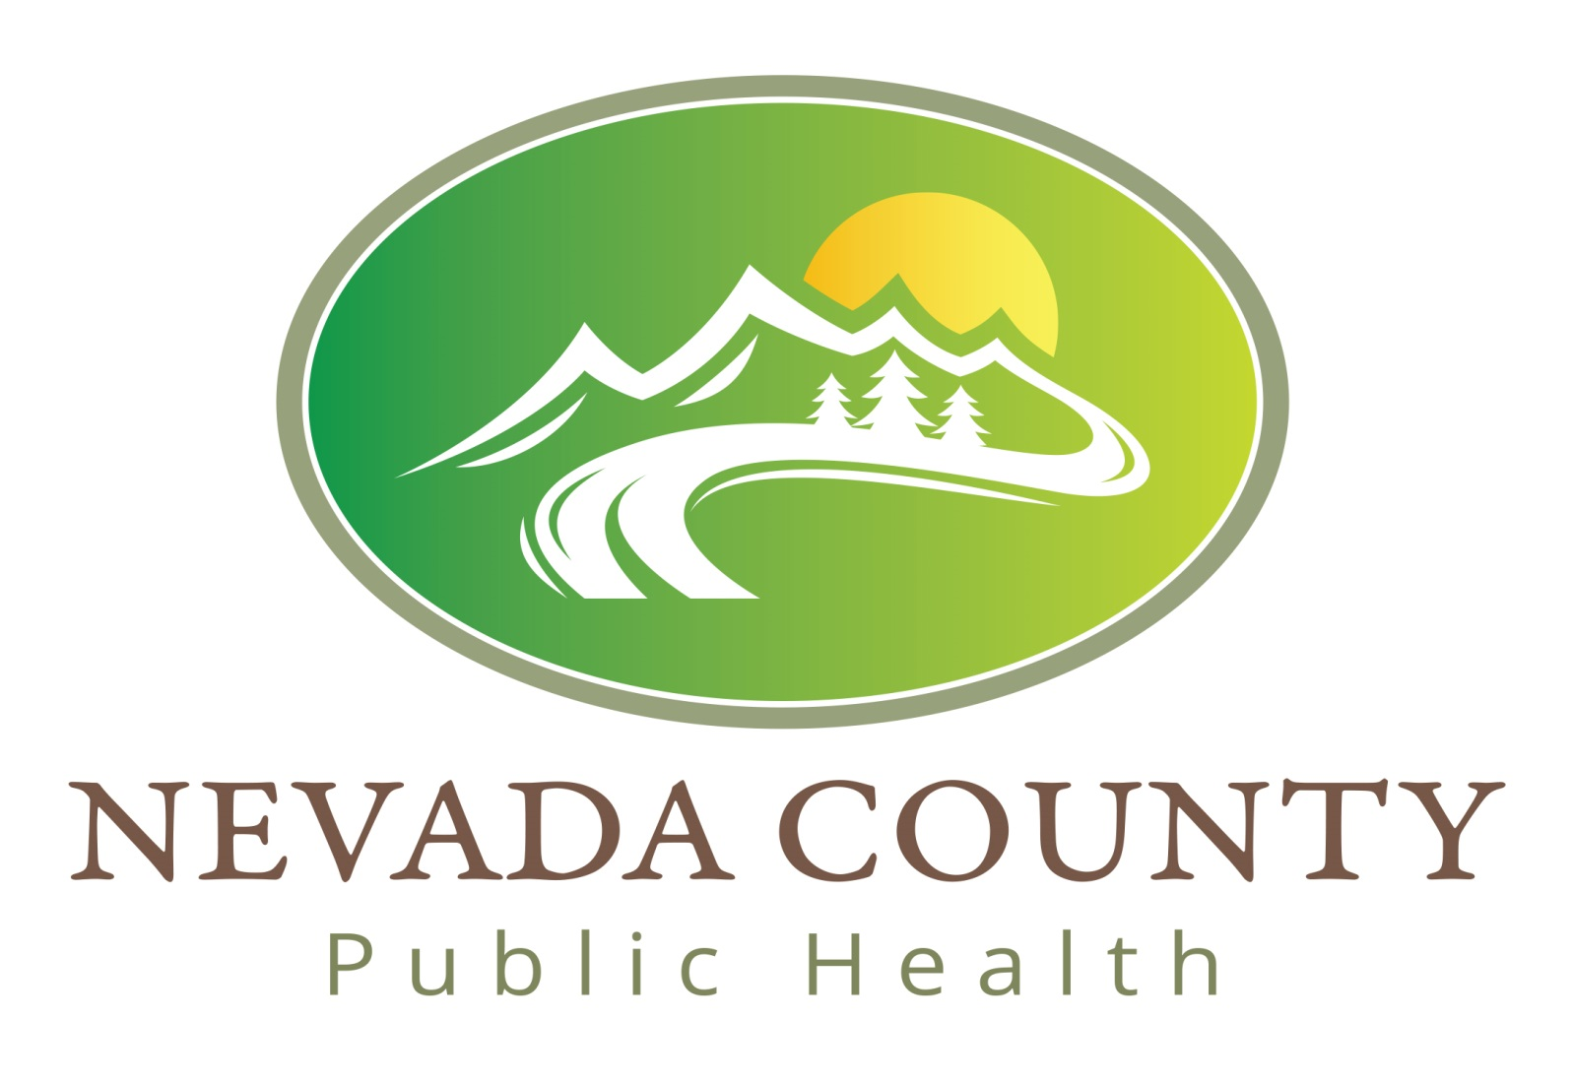

Nevada County would like to know your opinion about certain tobacco products. We do not need your name or contact information, just some information about you and your opinions. If any questions make you feel uncomfortable, you do not need to answer them. Thank you for your time!
- Your zip code? ______________

- What year you were born? ___________

- Your gender? Female Male Other

- Have you ever seen cigarillos (little cigars) being sold in a convenience store, gas station or other store that sells tobacco?
Yes No
- Have you ever smoked a cigarillos (little cigar)?
Yes No
- Has someone you know ever purchased or smoked a cigarillos (little cigar)?
Yes No
- If you were to smoke a cigarillos (little cigar), would you prefer to smoke one that is flavored, such as grape or Pina` Colada, or unflavored?
Flavored Unflavored
- Who do you think is more likely to smoke a cigarillos (little cigar)?
Youth Adults Both
- Who do you think is more likely to smoke a flavored cigarillos (little cigar)?
Youth Adults Both
- What do you think is the average price for one cigarillos (little cigar)?
Less than $1.00 $1.00 $2.00
- Cigarillos are sold in packs of two or more and also as singles. Would you support a law that bans the sale of single cigarillos?
Yes No Not sure

